ABINAV S T  
 230701007

EXP NO:4a Employee Average Pay

PROGRAM

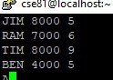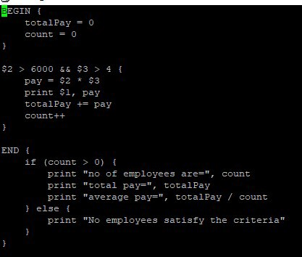

OUTPUT

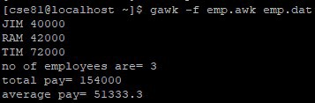

EXP NO:4b Results of Examination

PROGRAM

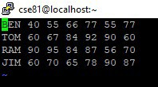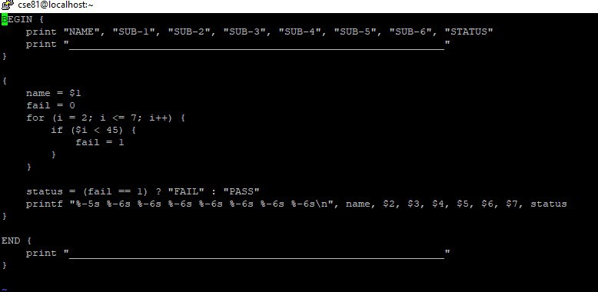

OUTPUT

